APPENDIX A
PHOTOGRAPHS TAKEN DURING JIV AT 6” TUOMO/OGBOINBIRI PIPELINE AT AZAMA COMMUNITY, SOUTHERN IJAW L.G.A, BAYELSA STATE ON 24TH JUNE, 2024.
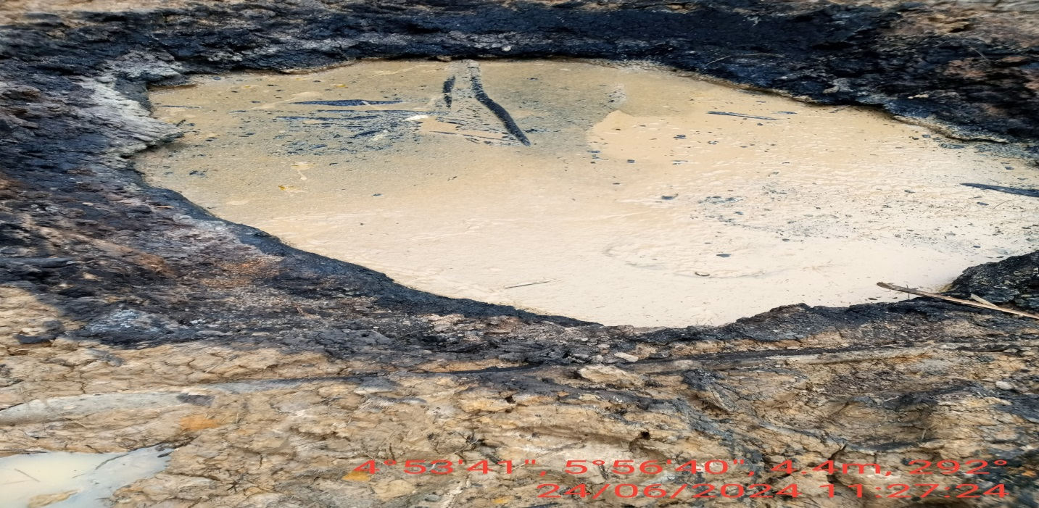FIG.1: THE INCIDENT POINT BEFORE EXCAVATION.
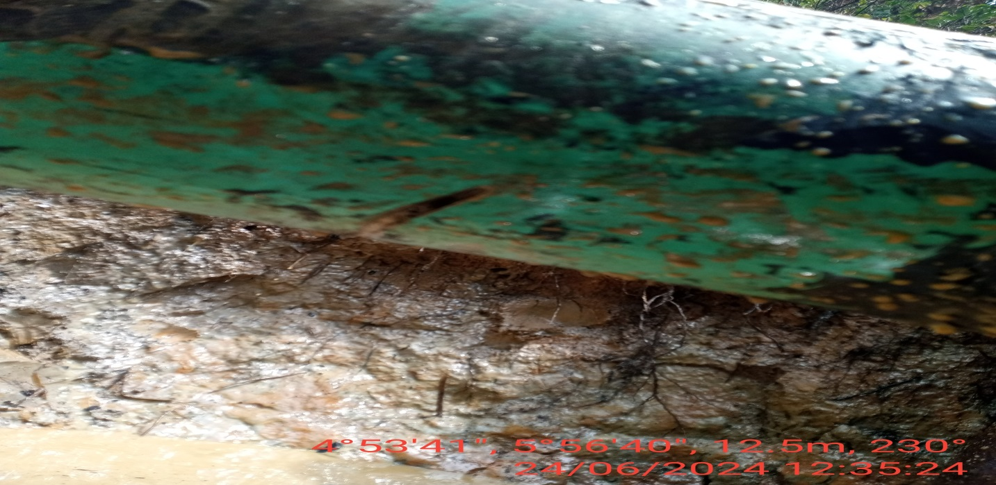
FIG.2: ABOUT 100MM CUT MADE AT 6 O’ CLOCK POSITION OF THE PIPELINE USING A CUTTING DEVICE BY VANDALS.

